Java Streams — Employee Management
Employee Model
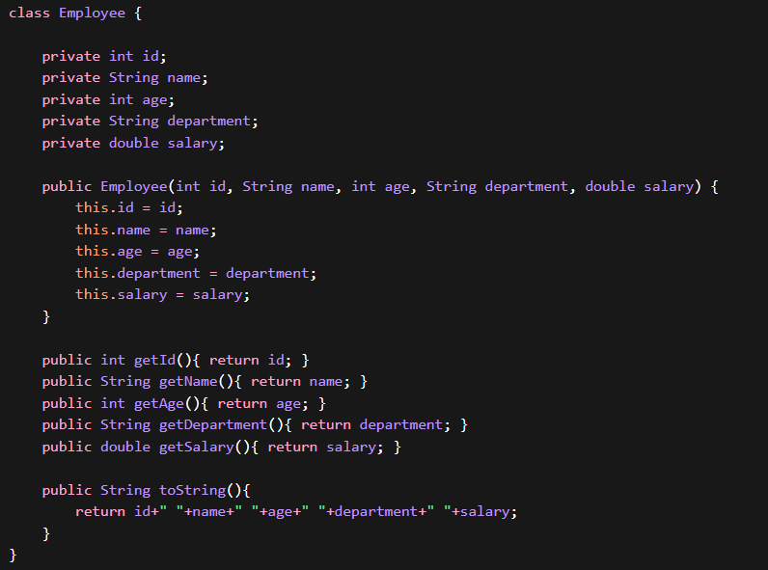
Dataset
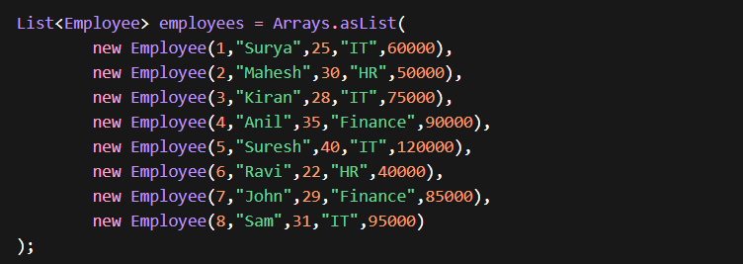

Part – A: Core Stream Operations
1.Print All Employees

2.Extract Employee Names

3.Extract Employee Salaries

4. Filter Employees Salary > 70000

5. Filter Employees From IT Department

6. Total Employee Count

7. HR Employee Count
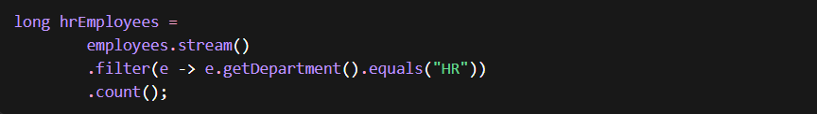
8. Highest Salaried Employee (Sorted)
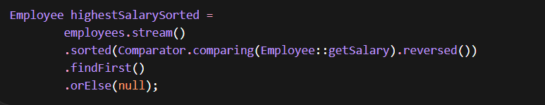
9. Highest Salaried Employee (max)

10. Lowest Salary Employee
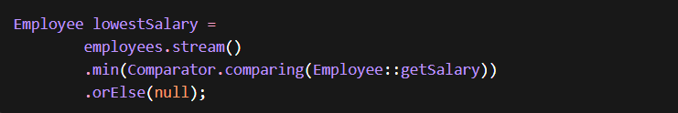
11. Average Salary
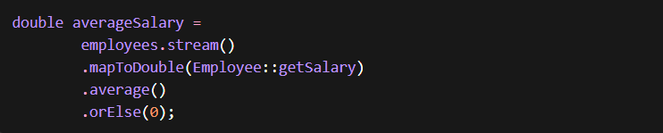

12. Total Salary Using SUM
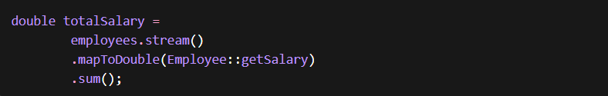
13. Total Salary Using Reduce
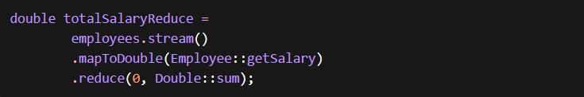
14. Sort Employees by Salary

15. Sort Employees by Salary Descending
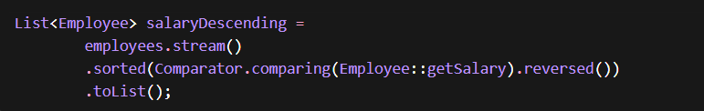
16. Distinct Departments

17. Group Employees by Department

18. Count Employees Per Department
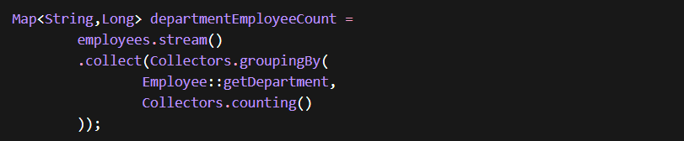
19. Average Salary Per Department
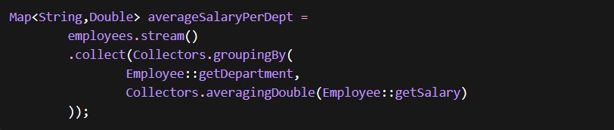
20. Highest Salary Employee Per Department
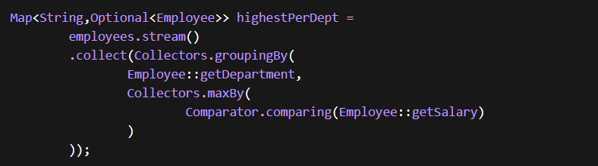
21. Partition Employees Salary > 70000
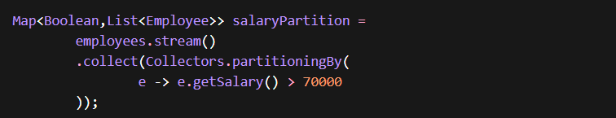

22. Second Highest Salary
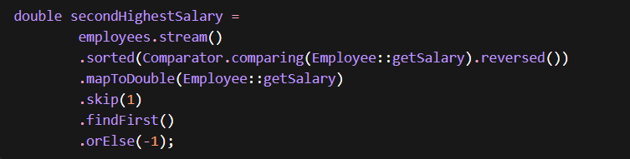
23. Second Highest Salary Employee
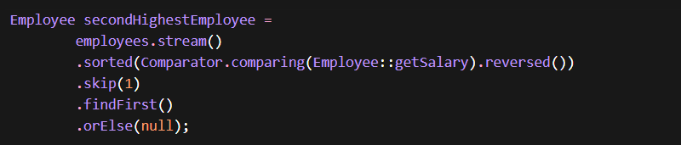
24. Department With Highest Average Salary
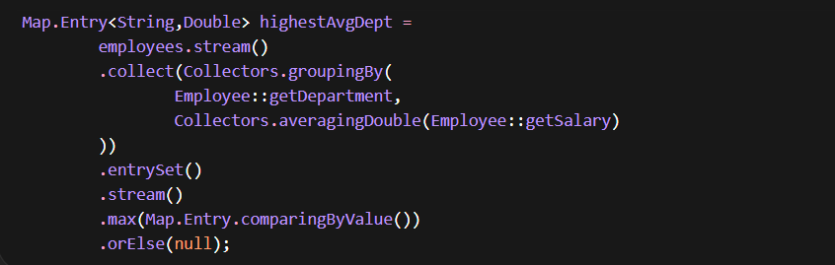
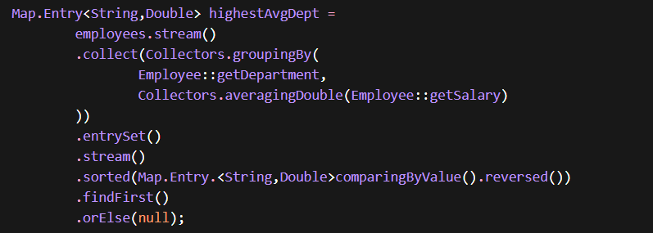
25. Department With Most Employees
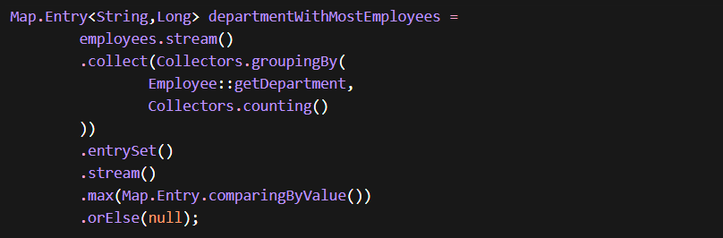

Part B – Ranking / Sorting / Filtering Problems
26. Employees With Salary Above Average
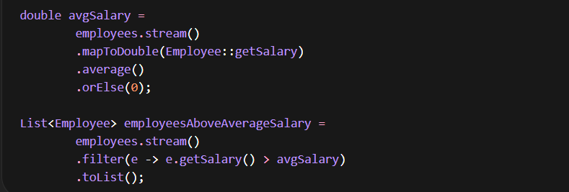
27. Employees With Salary Below Average

28. Employees Older Than 30

29. Count Employees Older Than 30
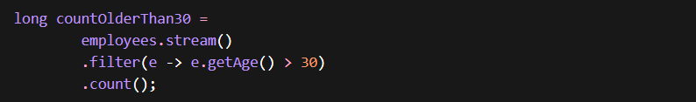
30. Youngest Employee

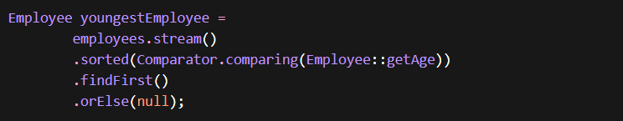
31. Oldest Employee

32. Employee Names Sorted Alphabetically
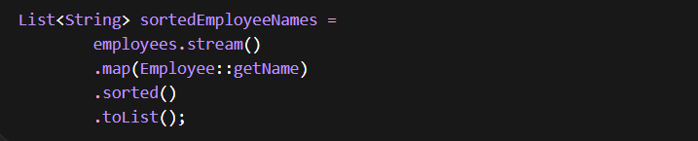
33. Sort Employees by Age

34. Sort Employees by Age Descending

35. Sort Employees by Department then Salary
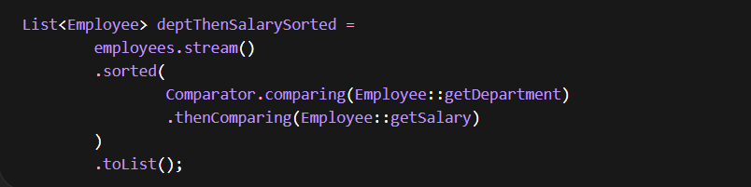
36. Employees Salary Between 50000 and 90000
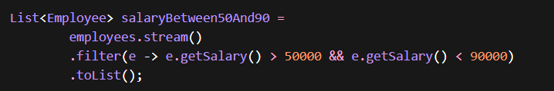
37. Employee Names in Uppercase

38. Map Employee Name → Salary
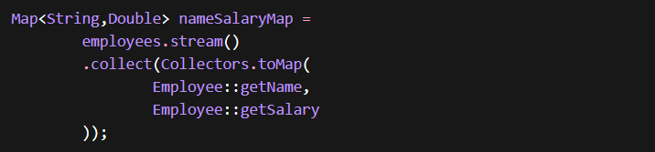
39. Map Employee ID → Employee Object

40. Average Employee Age
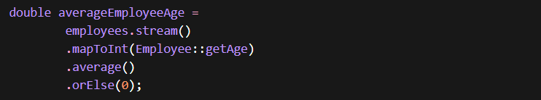
41. Group Employees by Age

42. Group Employees by Department and Count
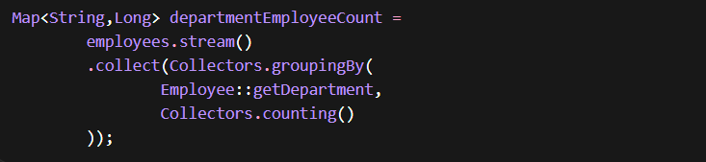
43. Department Wise Total Salary
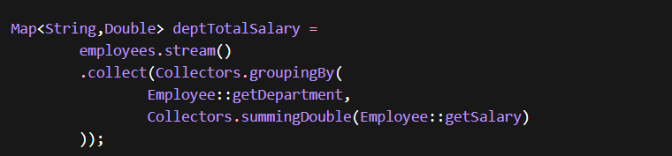
44. Group Employees by Department and List Names
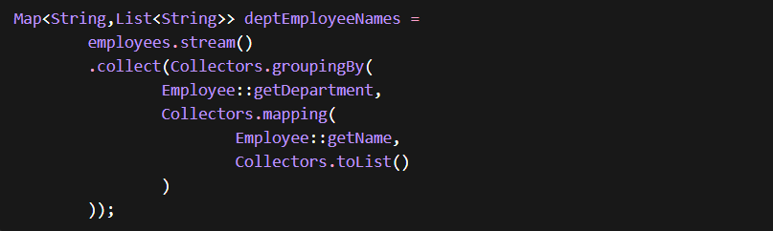
45. Department Wise Average Age
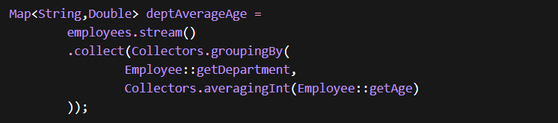
46.Partition Employees Age > 30

47. Partition Employees Salary > 80000
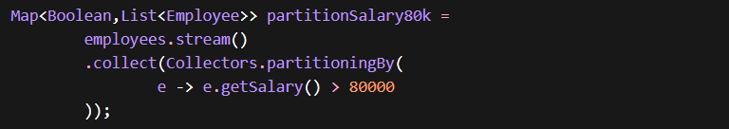

48. Top 5 Highest Paid Employees
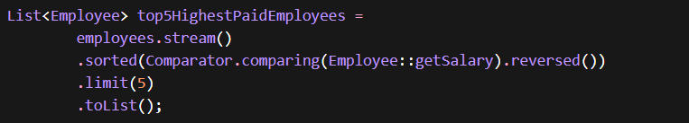
49. Bottom 3 Salaried Employees
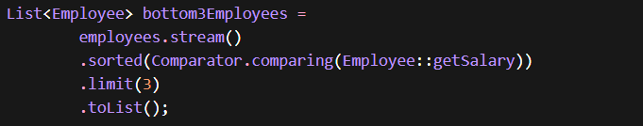
50. Bottom 3 Salaries Only


Part C – Grouping / Collectors / Aggregations
51. Employee Name → Salary Map
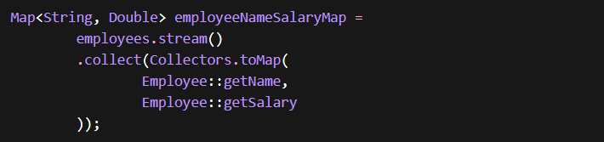
52. Employee ID → Employee Map

53. Group Employees by Department
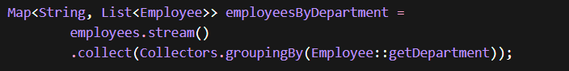
54. Count Employees per Department
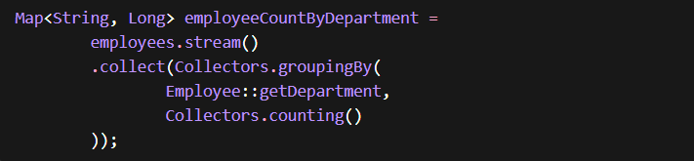

55. Average Salary per Department
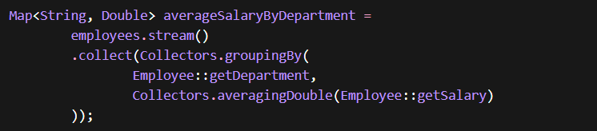
56. Sum of Salaries per Department
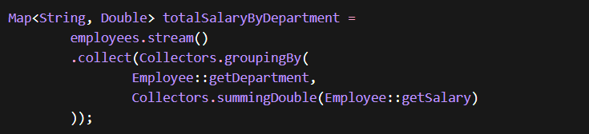
57. Employees Names per Department
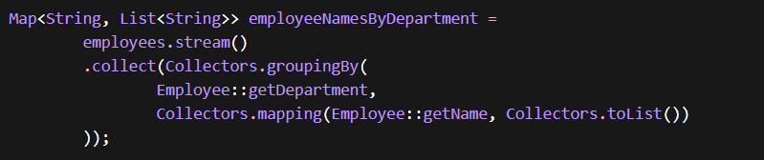
58. Department → List of Salaries
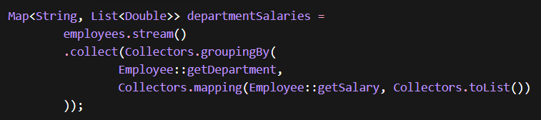

59. Highest Salary Employee per Department
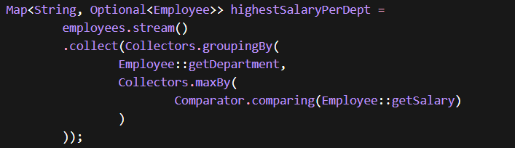
60. Lowest Salary Employee per Department
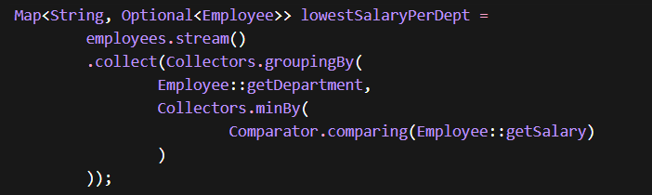
61. Department → Highest Salary Value
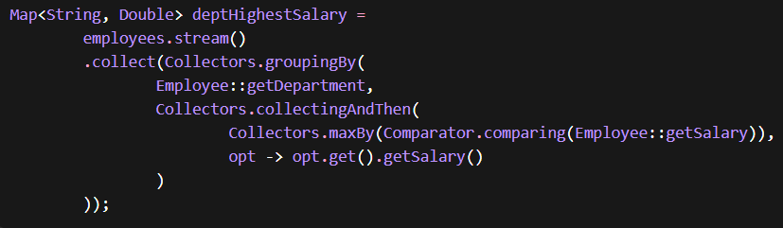
62. Group Employees by Age


63. Count Employees per Age
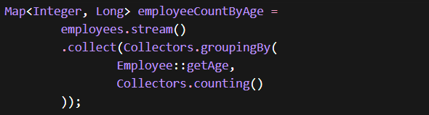
64.Partition Employees Salary > 70000

65. Partition Employees Age > 30
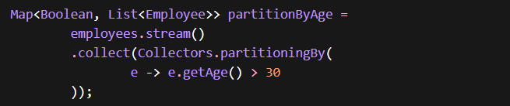
66. Employee First Letter Frequency


67. Employees Grouped by First Letter
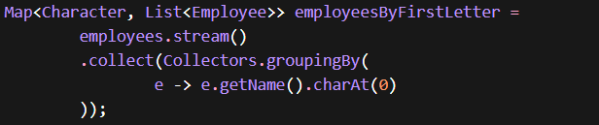
68. Most Common First Letter
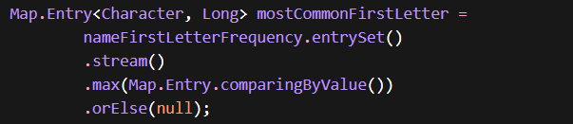
69. Salary Summary Statistics
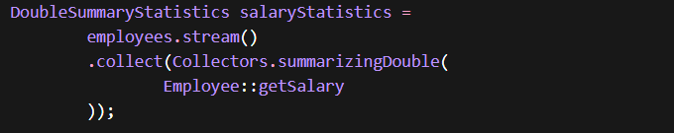
70. Age Summary Statistics
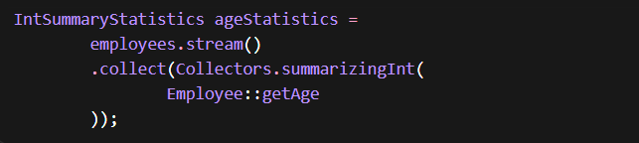
71. Department → Employee Count (Sorted)

72. Department → Total Salary (Sorted)
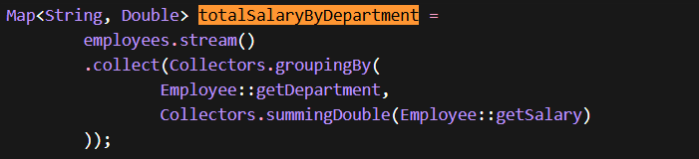
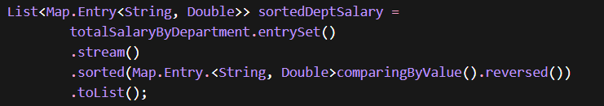
73. Department With Highest Salary Sum
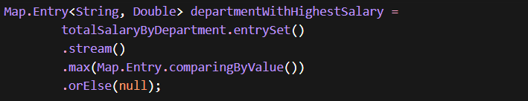
74. Department With Lowest Salary Sum
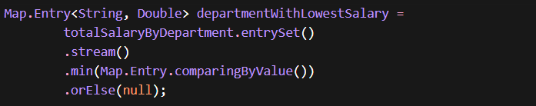
75. Department With Most Employees
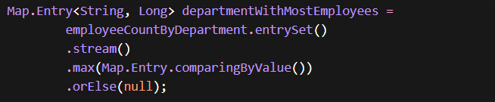

76. Department With Least Employees
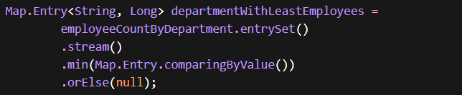
77. Department → Employee Names Sorted by Salary
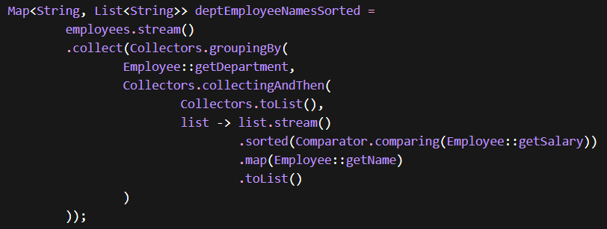
78. Top Paid Employee per Department (Flattened)
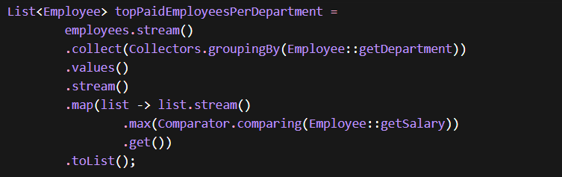

79. Department → Highest and Lowest Salary Statistics
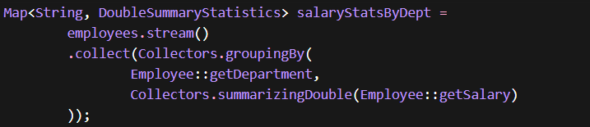
80. Departments Sorted Alphabetically
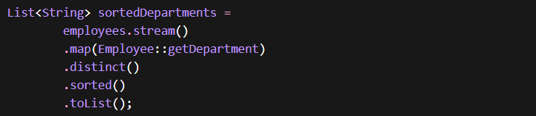

Part D – Advanced Stream Analytics
81.Salary Range (Max - Min)
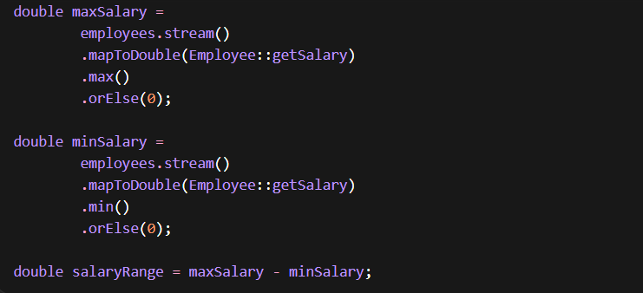
82. Department With Lowest Average Salary
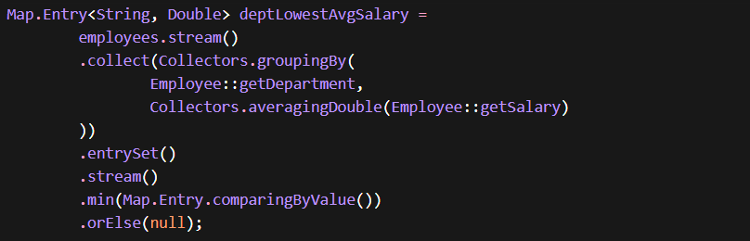
83. Department → Average Salary Map
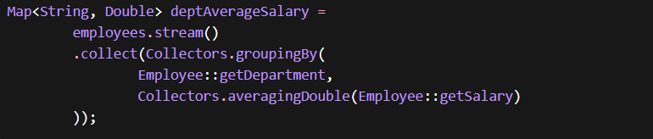

84. Employees With Salary Greater Than Department Average
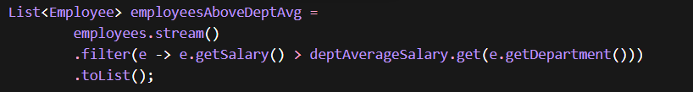
85. Employees Above Overall Average Salary
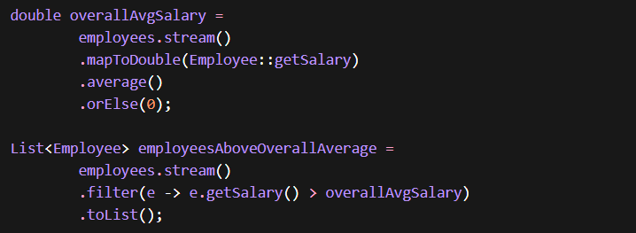
86.Department → Highest Salary Value Map
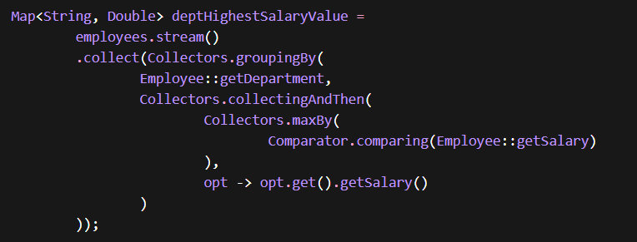

87.Department → Employee Names Sorted By Salary
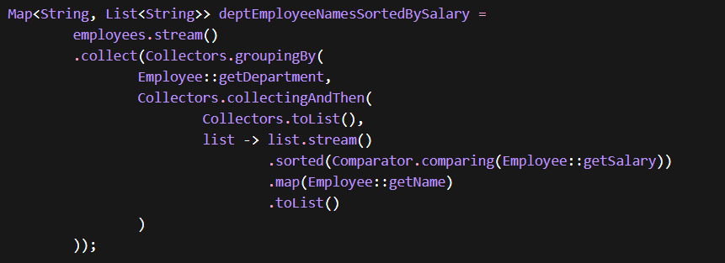
88. Employees With Maximum Name Length
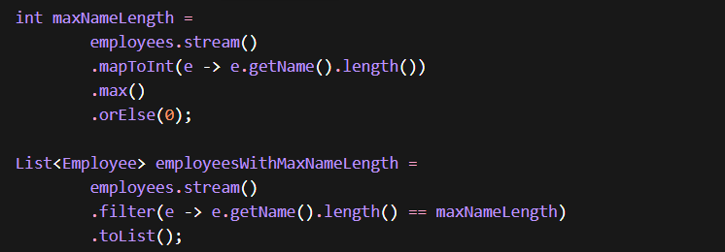
89.Department With Highest Paid Employee
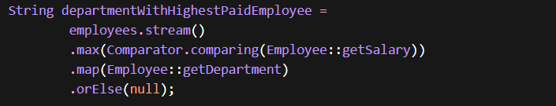

90. Employees With Duplicate Names
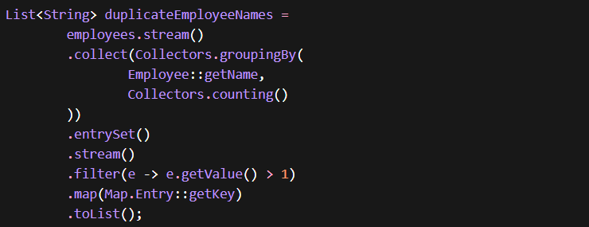
91. Department → Total Salary Sorted Desc
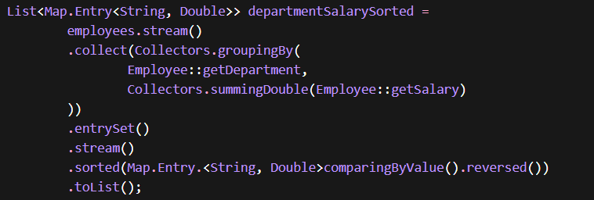
92. Top Paid Employee Per Department (Flattened)
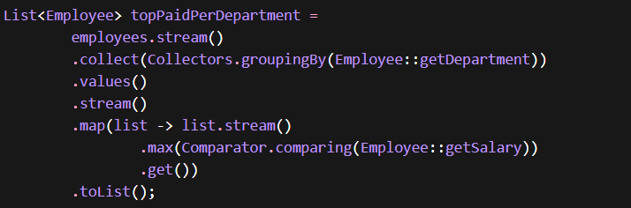

93. Department With Youngest Average Age
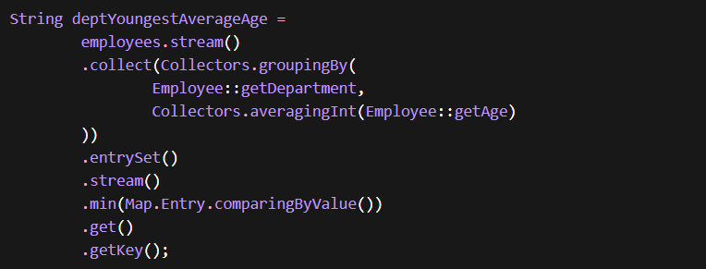
94.Department → List of Salaries
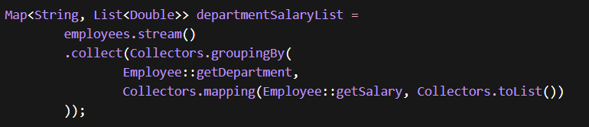
95. Employees Earning More Than Their Department Average
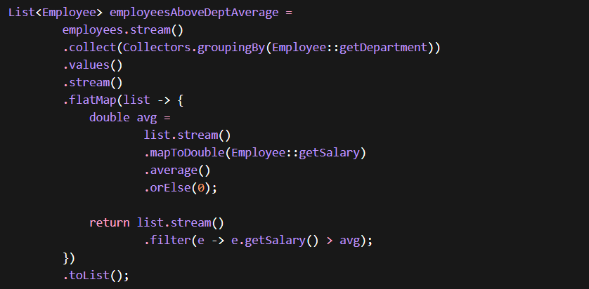

96. Employee Count Per Salary Range
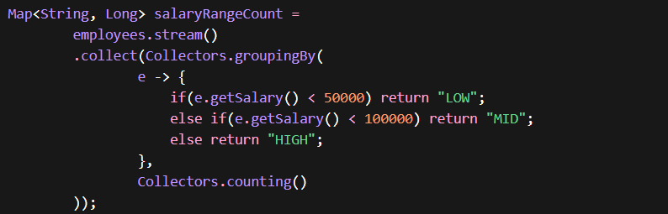
97. Longest Name Employee Per Department
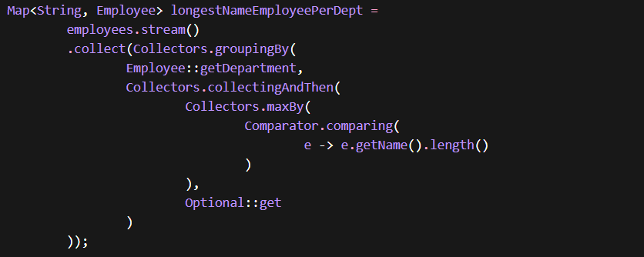
98. Flatten Department → Employee Names
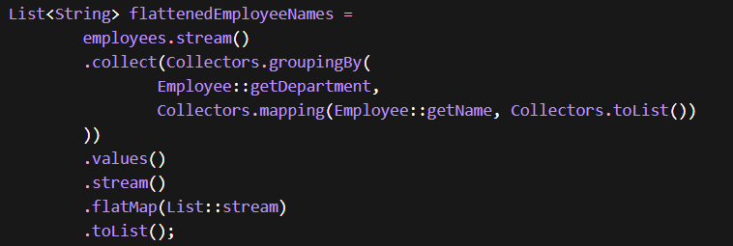

99. Salary Percentage Contribution Per Employee
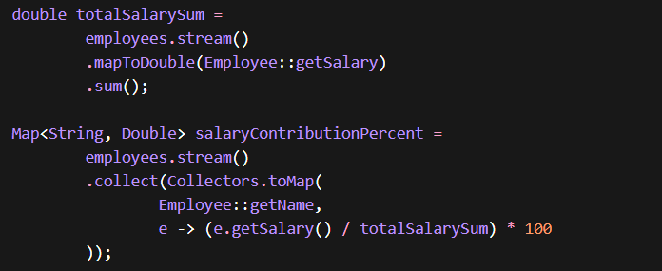
100. Group Employees By Age Range
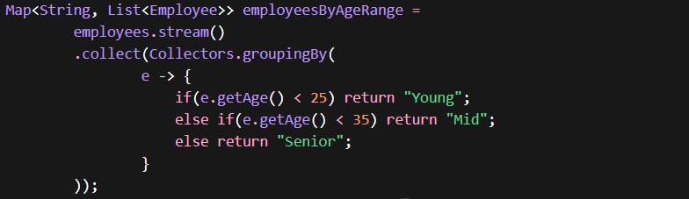
101. Employee Closest To Average Salary
